Loan Data Report
Introduction
The loan dataset offers comprehensive insights into applicants' details like gender, marital status, education, income, loan amount, and property area. This analysis aims to uncover patterns and demographics using pivot tables and charts. Understanding these nuances is crucial for financial institutions to optimize lending processes and cater to diverse customer needs effectively. The insights derived will inform strategic decisions and enhance loan management systems' efficiency.
Questionnaire
1. How many male graduates who are not married applied for Loan? What was the highest amount?
2. How many female graduates who are not married applied for Loan? What was the highest amount?
3. How many male non-graduates who are not married applied for Loan? What was the highest amount?
4. How many female graduates who are married applied for Loan? What was the highest amount?
5. How many male and female who are not married applied for Loan? Compare Urban, Semi-urban and rural based on amount.
Analytics
Q1. How many male graduates who are not married applied for Loan? What was the highest amount?
ANS: This analysis shows the no. of male graduates applied for the loan and are not married with the highest amount. As of analysed the total no. of loan applied is 66 and max loan amount is 240.

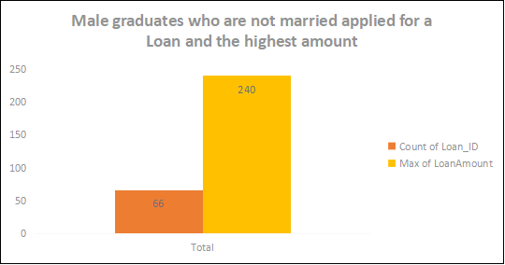
Q2. How many female graduates who are not married applied for Loan? What was the highest amount?
ANS: This analysis shows the no. of female graduates applied for the loan and are not married with the highest amount. As of analyzed the total no. of loan applied is 35 and max loan amount is 300.

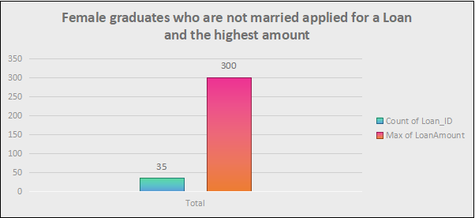

Q3. How many male non-graduates who are not married applied for Loan? What was the highest amount?
ANS: The analysis reveals that among loan applicants, the highest number consists of unmarried male non-graduates, with a total of 16 applications. The maximum loan amount requested is $199.

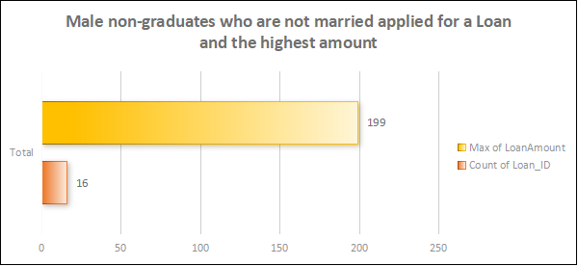

Q4. How many female graduates who are married applied for Loan? What was the highest amount?
ANS: The analysis indicates that the highest number of loan applicants are unmarried female graduates, totaling 21 applications. The maximum loan amount requested among them is $460.
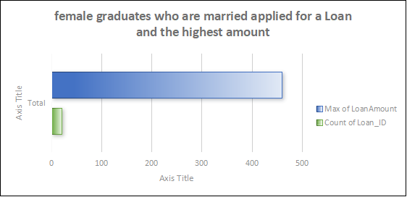
Q5. How many male and female who are not married applied for Loan? Compare Urban, Semi-urban and rural based on amount.
ANS: This analysis compares loan applications from unmarried females and males across rural, semi-urban, and urban areas. Females have lower application counts: rural (1,732), semi-urban (1,806), and urban (1,716). In contrast, males show significantly higher counts: rural (3,244), semi-urban (3,359), and urban (3,451), indicating a gender disparity in loan applications.
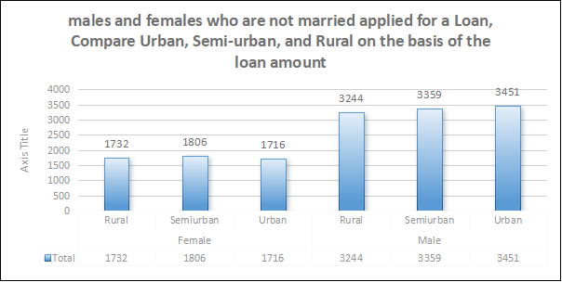

Conclusion and Review
The analysis reveals stark gender disparities in loan applications, with unmarried male graduates leading, followed by unmarried female graduates. Smaller numbers of unmarried male non-graduates and married female graduates also applied. Males outnumbered females across rural, semi-urban, and urban areas. The report effectively illustrates gender-based trends, offering valuable insights into borrower demographics, while suggesting further exploration and visual enhancements for deeper insights.
Regression
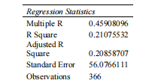
ANOVA
 | df | SS | MS | F | Significance F
Regression | 3 | 289502.8035 | 96500.93 | 37.32019 | 2.25609E-20
Residual | 285 | 736940.7397 | 2585.757
Total | 288 | 1026443.543
 | Coefficients | Standard Error | t Stat | P-value | Lower 95% | Upper 95% | Lower 95.0% | Upper 95.0%
Intercept | 66.690952 | 16.26833015 | 4.099434 | 5.41E-05 | 34.66963005 | 98.71227396 | 34.66963 | 98.71227
X Variable 1 | 0.095771273 | 0.045649816 | 2.097955 | 0.03679 | 0.005917708 | 0.185624838 | 0.005918 | 0.185625
X Variable 2 | 0.005807787 | 0.000627861 | 9.250122 | 5.49E-18 | 0.004571955 | 0.007043619 | 0.004572 | 0.007044
X Variable 3 | 0.006772797 | 0.001264765 | 5.354983 | 1.76E-07 | 0.004283331 | 0.009262263 | 0.004283 | 0.009262

Descriptive Statistics
Column1 |  | Column2 |  | Column3 |  | Column4
Mean | 342.6713 | Mean | 4637.353 | Mean | 1528.263 | Mean | 136.7924
Standard Error | 3.862088 | Standard Error | 281.8049 | Standard Error | 139.8588 | Standard Error | 3.51174
Median | 360 | Median | 3833 | Median | 879 | Median | 126
Mode | 360 | Mode | 5000 | Mode | 0 | Mode | 150
Standard Deviation | 65.6555 | Standard Deviation | 4790.684 | Standard Deviation | 2377.599 | Standard Deviation | 59.69958
Sample Variance | 4310.645 | Sample Variance | 22950653 | Sample Variance | 5652978 | Sample Variance | 3564.04
Kurtosis | 8.62994 | Kurtosis | 141.612 | Kurtosis | 32.96701 | Kurtosis | 5.739804
Skewness | -2.64147 | Skewness | 10.41123 | Skewness | 4.510775 | Skewness | 1.780616
Range | 474 | Range | 72529 | Range | 24000 | Range | 432
Minimum | 6 | Minimum | 0 | Minimum | 0 | Minimum | 28
Maximum | 480 | Maximum | 72529 | Maximum | 24000 | Maximum | 460
Sum | 99032 | Sum | 1340195 | Sum | 441668 | Sum | 39533
Count | 289 | Count | 289 | Count | 289 | Count | 289

Correlation

 | Column 1 | Column 2 | Column 3
Column 1 | 1
Column 2 | -0.08435 | 1
Column 3 | 0.445695 | 0.230355 | 1

